How to use

1. Your excel sheet should be formatted to the “.xlsx” format. This is by default so do not change it!
2. Your excel sheet should be formatted like this. Do NOT have more than one column after your artwork. You should not have multiple artworks on the same excel sheet. Create multiple excel files for each artwork e.g title name, enemy, player etc.  
   Ensure your sheet name is “Sheet1”.

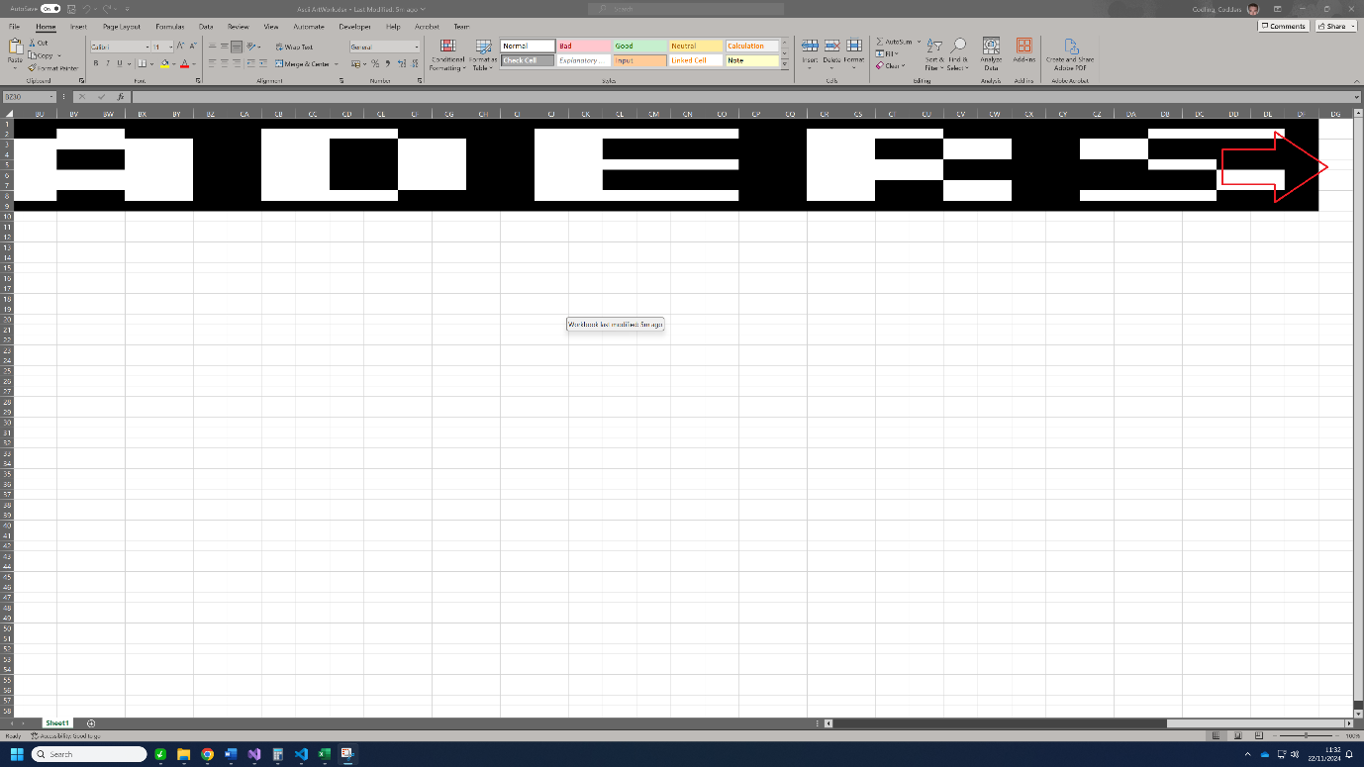

1. Change the name of the excel sheet to open in the python file to the respective name you have called yours. In my case, mine is called “Ascii ArtWork.xlsx”. Ensure the python code is in the same folder as the excel sheet! 
2. Run the python code. Remember the number of columns and rows your artwork has. The python code will tell you this.
3. Open the “Text.txt” file. Copy everything in there using Ctrl+A, Ctrl+C.
4. 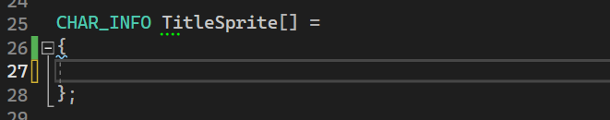Copy the contents into the sprite you are using. For my case I’m using it for the title shown below.

In my case it looks like this: 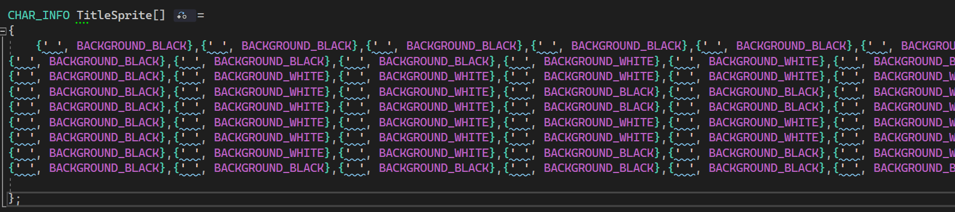

1. Go to your “game.cpp” file and your artwork “.SetPosition” function call. Like this: 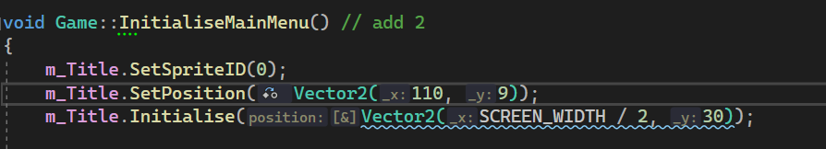

In my case, I have 110 columns and 9 rows. Remember the python code will tell you this.